Project Plan

< Victoria Road Crash Dataset >

Group 52

Student Names

S5219071 Inho Kim

Table of Contents

1.0 Introduction 3

1.1 Problem Background 3

1.2 Scope 3

1.3 Document contents 3

2.0 Work Breakdown Structure 4

3.0 Activity Definition & Estimation 5

4.0 Gantt Chart 6

# Introduction

## Background

The development of this study will be developed to provide road safety data based on time, location, condition, type of collision, type of road user, object hit. based on Victoria Road Crash Dataset provided by Vircord. To reduce traffic accidents and risks in Victoria. In addition, the software analyzes the point of occurrence of an accident and provides visualized insight to help user understand.

## Scope

Document work for this study will be completed prior to the final submission on September 2, including the Gantt Chart, after which the project will be developed according to the schedule assigned to WBS, and the software and all document work will be uploaded to GitHub by October 9, the final project deadline.

**Interface**

Interfaces should be developed in a structure that is easy for customers to recognize. Use the Python program to develop this study, enter the information you want your customers to know from the dataset, and simply print it out. In addition, when visualization data is required, results are required to be printed to the customer on a pie chart so that the customer can easily see it at a glance. The deployment of the interface makes about seven days and ensures that all functional interfaces are in place before the final deadline.

**Time**

The time of incident on Victoria State Road should allow data to be available in the order in which the customer needs information. Customers can sort the time of the incident in the latest, oldest order and determine when the incident occurred. This takes a total of four days and closes four days after the basic interface is made.

**location**

Information is provided to customers through statistics on places and places where road accidents occur frequently. Information on the area and location of the accident should be secured to ensure safe operation when the customer reaches the area. This takes a total of four days and closes four days after the basic interface is made.

**Conditions**

**Crash type**

To ensure the customer's collision prevention safety, each type of road accident collision must be provided. The development period is 4 days.

**Road user type**

* **Object hit**

## Document contents

*Include some background information about the problem, the scope and what this document will contain.*

# Work Breakdown Structure

Our team is organized and each person is assigned a role to complete this project by the project deadline (October 9 and 22). Allocated work is performed on all days except weekends and holidays, and in terms of roles, each has a primary role, which means that we do most of the work and then play a secondary role.

From an external group's point of view, our main external group is the customer. We work closely with our customers to ensure that efficient communication is maintained and their feedback communicates and maintains their vision of the project.

**Member Name:** Inho Kim

**Roles (Primary/Secondary):** Project Manager, Developer/Tester

**Responsibilities:** Inho Kim is in charge of project planning, activity definition, and work schedule, and project development with the roles of project manager, developer

**Member Name:** Saikat Dutta Tanu

**Roles (Primary/Secondary):** Project Designer, Developer/Tester

**Responsibilities:** Saikat is responsible for designing and developing software features and interfaces.

This chart is a project activity that uses elements from WBS to create activity definitions.

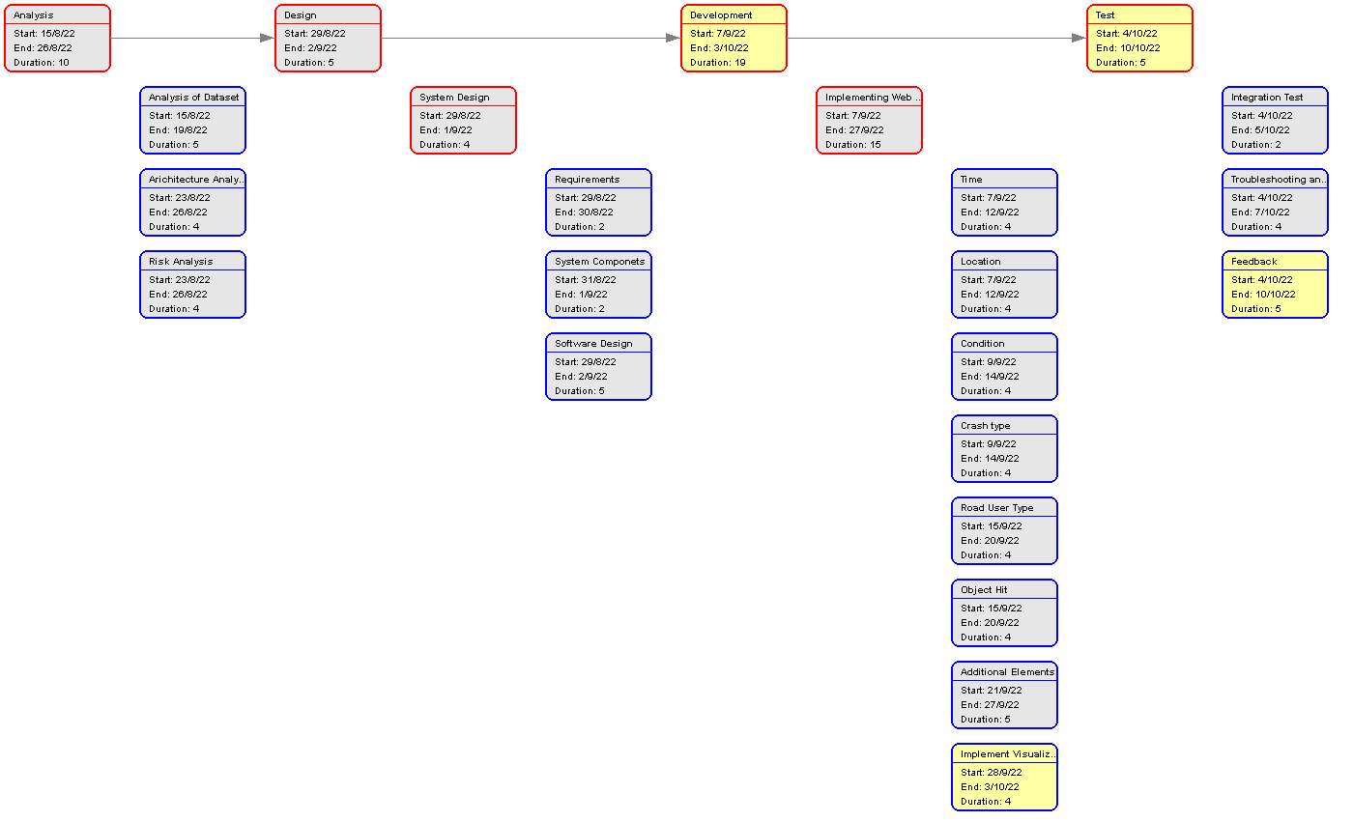

# Activity Definition & Estimation

|  |  |  |  |  |  |  |  |
| --- | --- | --- | --- | --- | --- | --- | --- |
| *1* | *Analysis* | *-* | *-* | *15-08-22* | *26-08-22* | *10* | *100%* |
| *1.1* | *Analysis of Dataset* | *IK* | *Completed* | *15-08-22* | *19-08-22* | *5* | *100%* |
| *1.2* | *Architecture Analysis* | *IK* | *Completed* | *23-08-22* | *26-08-22* | *4* | *100%* |
| *1.3* | *Risk Analysis* | *IK* | *Completed* | *23-08-22* | *26-08-22* | *4* | *100%* |
| *2* | *Design* | *-* | *-* | *29-08-22* | *02-09-22* | *5* | *100%* |
| *2.1* | *System Design* | *ST* | *Completed* | *29-08-22* | *01-09-22* | *4* | *100%* |
| *2.1.1* | *Requirements* | *ST* | *Completed* | *29-08-22* | *30-08-22* | *2* | *100%* |
| *2.1.2* | *System Components* | *ST* | *Completed* | *31-08-22* | *01-09-22* | *2* | *100%* |
| *2.3* | *Software Design* | *ST* | *Completed* | *29-08-22* | *02-09-22* | *5* | *100%* |
| *3* | *Development* | *-* | *-* | *07-09-22* | *03-10-22* | *19* | *-* |
| *3.1* | *Implementing Web Features* | *IK, ST* | *Not Started-* | *07-09-22* | *27-09-22* | *15* | *0%* |
| *3.1.1* | *Time* | *IK* | *Not Started-* | *07-09-22* | *12-09-22* | *4* | *0%* |
| *3.1.2* | *Location* | *IK* | *Not Started-* | *07-09-22* | *12-09-22* | *4* | *0%* |
| *3.1.3* | *Condition* | *IK* | *Not Started-* | *09-09-22* | *14-09-22* | *4* | *0%* |
| *3.1.4* | *Crash Type* | *ST* | *Not Started-* | *09-09-22* | *14-09-22* | *4* | *0%* |
| *3.1.5* | *Road User Type* | *ST* | *Not Started-* | *15-09-22* | *20-09-22* | *4* | *0%* |
| *3.1.6* | *Object Hit* | *ST* | *Not Started-* | *15-09-22* | *20-09-22* | *4* | *0%* |
| *3.1.7* | *Additional Elements* | *IK, ST* | *Not Started-* | *21-09-22* | *27-09-22* | *5* | *0%* |
| *3.2* | *Implement Visualization Capabilities* | IK, ST | *Not Started* | *28-09-22* | *03-10-22* | *4* | *0%* |
| *4* | *Test* | *-* | *-* | *04-10-22* | *07-10-22* | *5* | *-* |
| *4.1* | *Integration Test* | *IK, ST* | *Not Started-* | *04-10-22* | *05-10-22* | *2* | *0%* |
| *4.2* | *Troubleshooting and Issues* | *IK, ST* | *Not Started-* | *04-10-22* | *07-10-22* | *4* | *0%* |
| *4.3* | *Feedback* | *IK* | *Not Started-* | *04-10-22* | *07-10-22* | *5* | *0%* |

*From your WBS, define the activities required for your project. You will revise this document and add more detail for part B as you discover more about the project.*

*Each activity should be clearly identified by a number and should match up to your Gantt chart. You should provide some estimations for the time you think each activity will take. This should make it easy to prepare your Gantt chart.*

# Gantt Chart

